Goal: Reproduce Fig4b and plot new figures for 1M8

Figure 4b is shown below. The shaded region represents the region of oscillation. The plot corresponds to modified version of Kim-Forger PNF, PNNF, SNF and NNF models.

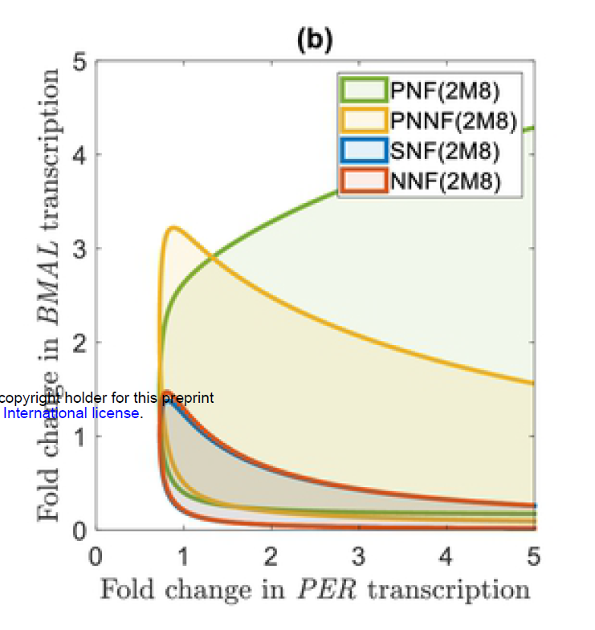

Step1: Write SNF_2M8.ode file

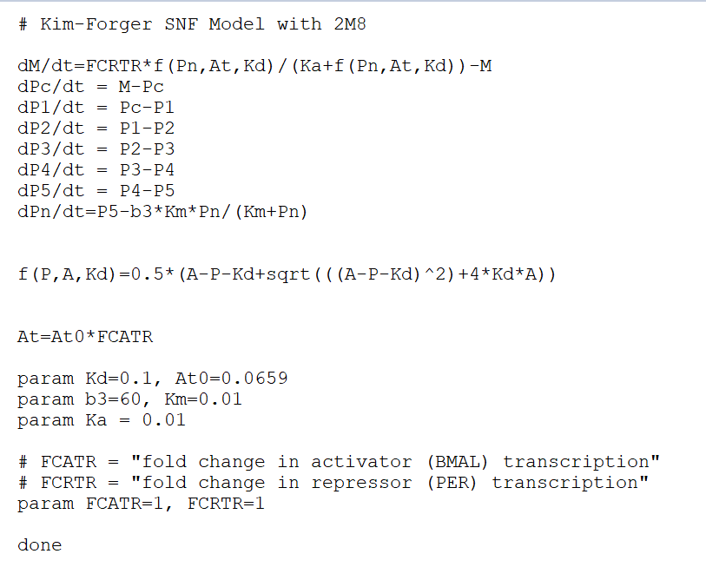

Step 2：Xpp-aut

grab HB and run two parameter bifurcation from 1) left to right

2) right to left

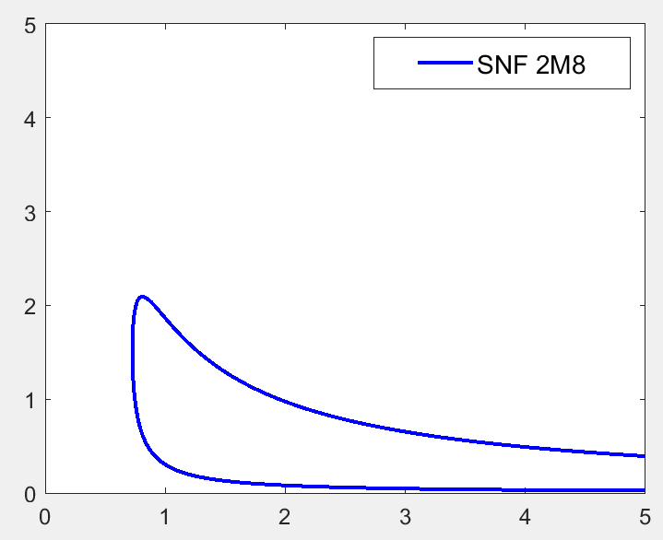

Modification of Kim-Forger NNF and PNF

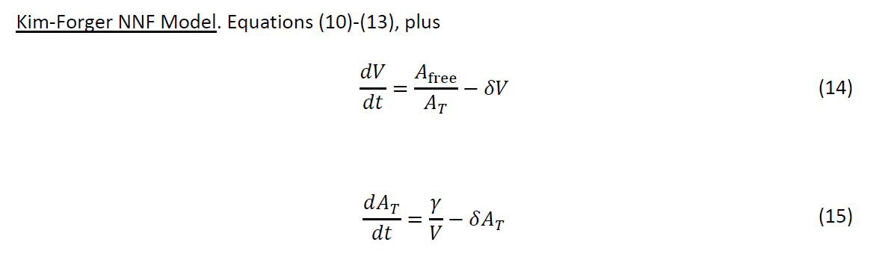

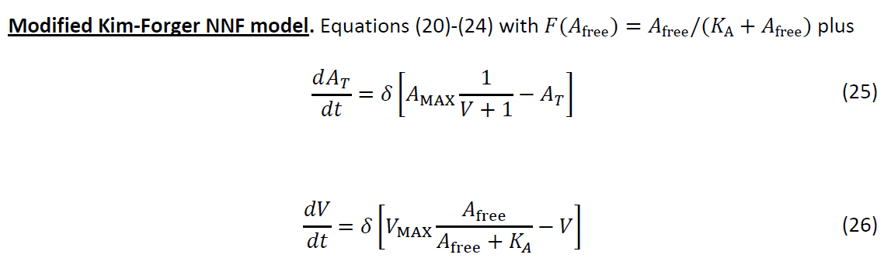

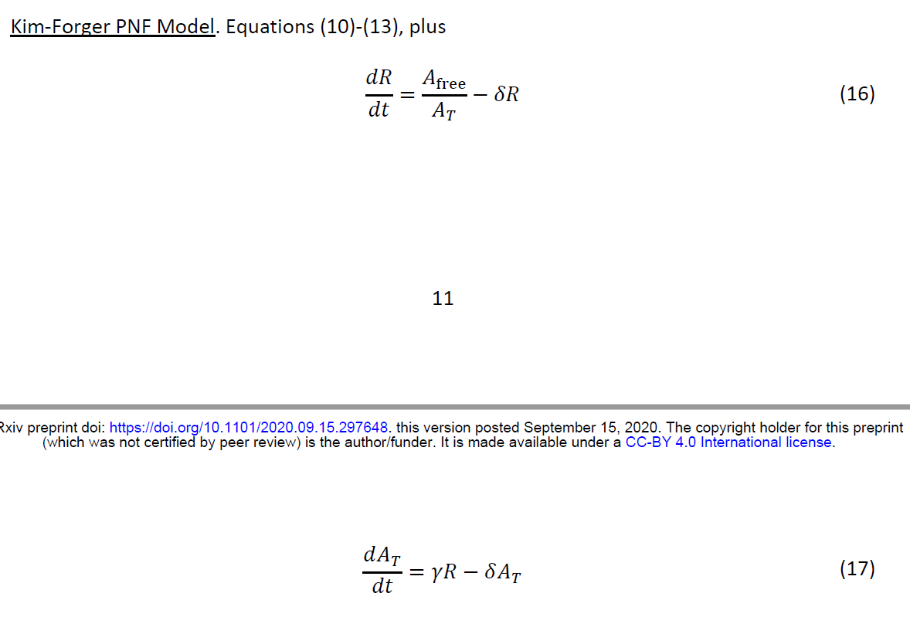

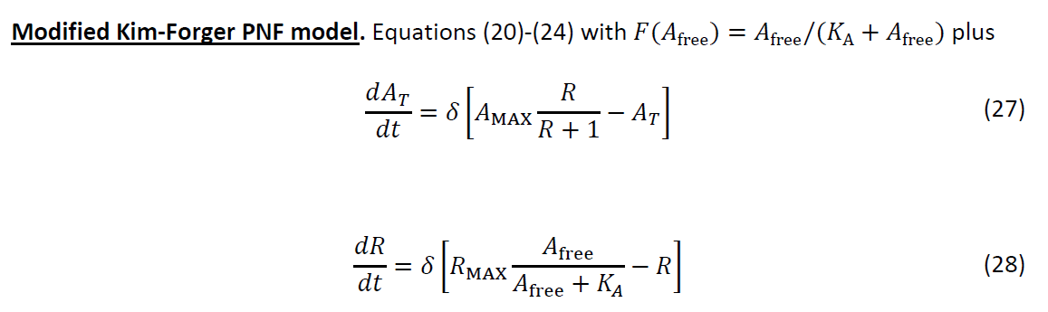

For plotting the patch figure in Matlab.

Step 1 Read .dat file

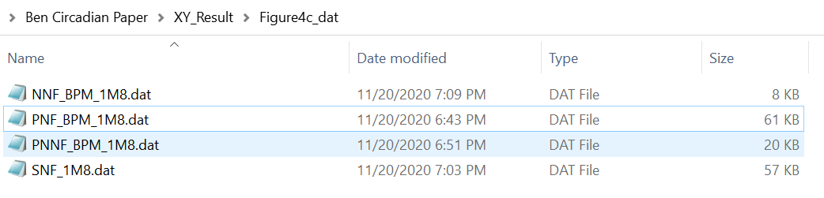

Step 2 Extract data point for 2 branches

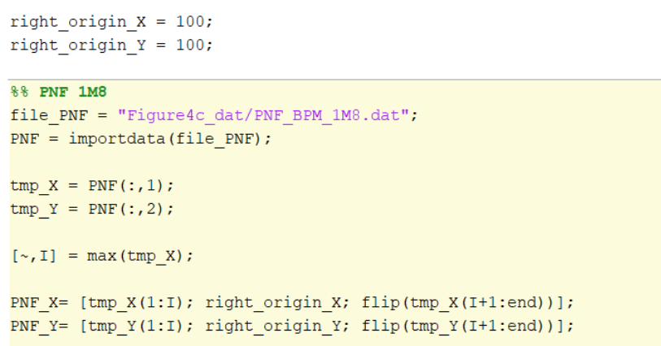

If we just focus on 0-5 fold change window, I can ignore the right above corner, therefore I use a very large number as right origin for patch plotting.

Step 3 Patch plot

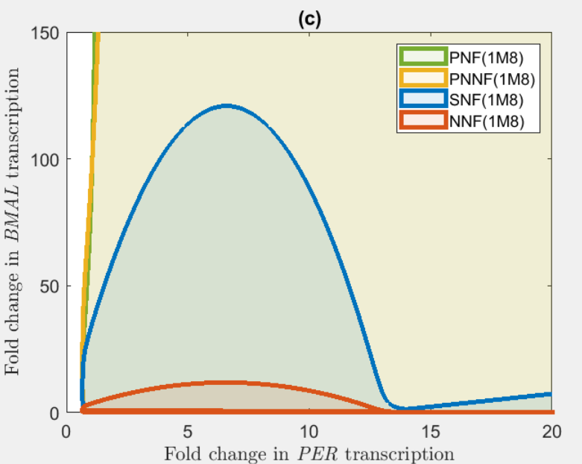

Issues raised by Jing

1. SNF(1M8) curves upward for FCRTR>15, which is a bit surprising. Could you pick a point in that small triangle, say, FCRTR=20, FCATR=5 (or maybe slightly smaller?), and make sure the model does oscillate in that area?
2. Could you run the bifurcation in a larger range for FCATR to find the upper boundary for PNF and PNNF? If it helps, you could try replacing FCATR by 10^FCATR first to quickly locate the relevant order of magnitude.
3. About the question in your previous email, I wonder if VMAX should be 1 for the NNF model since it is 1 for the PNNF model. Could you check with VMAX=1? If you indeed find VMAX=1, please also perform 4 and 5 below. Otherwise, let me know and I'll think again.
4. According to your description about the result with VMAX = 0.1, it sounds like smaller VMAX generates a smaller region of oscillation than Ben's result. If so, VMAX=1 probably would also enlarge the region of oscillation in your NNF(1M8) model. Please run NNF(1M8) with VMAX = 1 then.
5. Since the value of VMAX has a significant impact on the robustness of oscillation, RMAX may also have a significant impact. Could you just try RMAX = 1 and see if it makes the oscillation region smaller or larger?

XY’s answer

1. It is an artifact of my drawing. Corrected on shown below. (I used manually created boundary points for Matlab patch plotting to connect two branches)

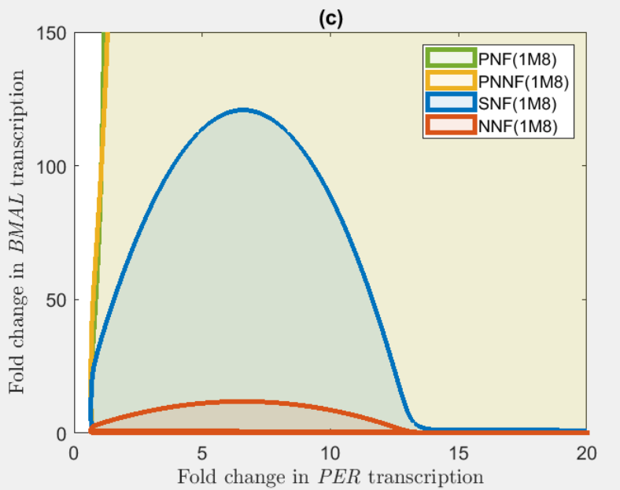

1. When FCRTR = 1, FCATR=1000 the system reaches fixed point for, the HB pts are ~1.24 and ~20.9

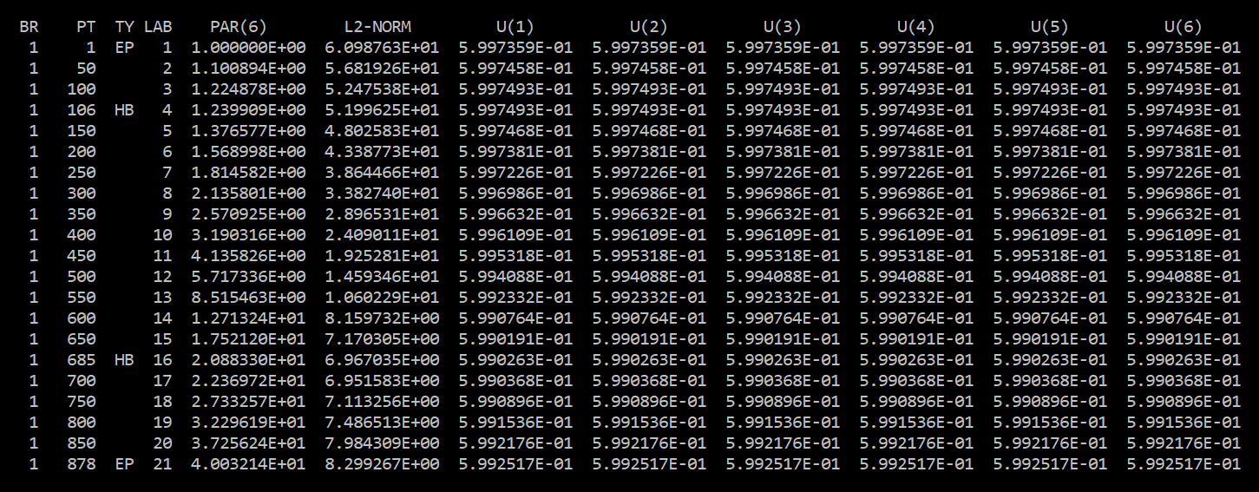

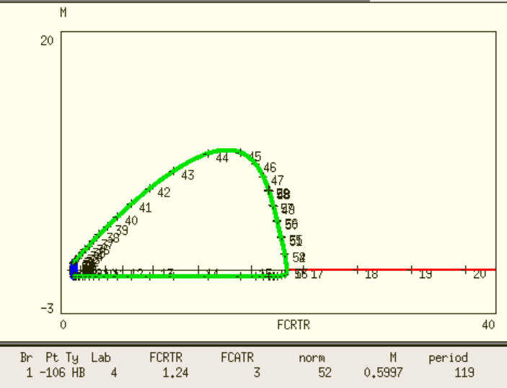

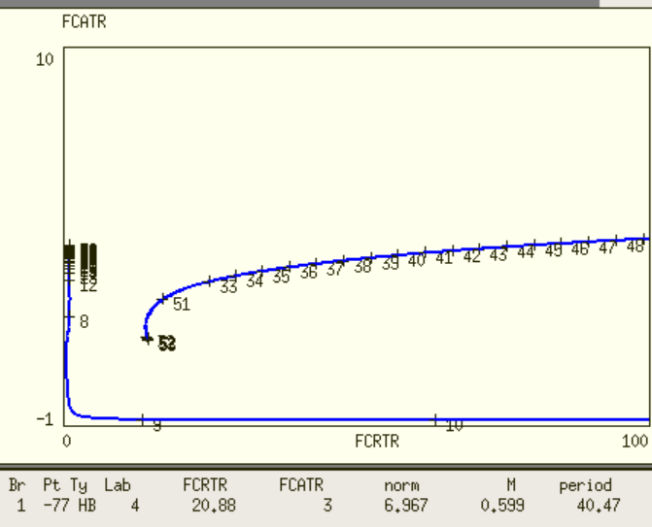

2-parameter bifurcation for PNF-1M8 ( y-axis is used as Amax = 10^FCATR)

Test of oscillatory region for PNF-1M8

|  |  |  |  |  |
| --- | --- | --- | --- | --- |
| Case Id | FCRTR | FCATR | Oscillatory(0 or 1) | Hopf pts |
| 1 | 1 | 10^4 | 0 | -0.26, 1.9 |
| 2 | 1 | 10^3 |  |  |
| 3 | 30 | 10^3 | 0 | 3.387, |
|  |  |  |  |  |
|  |  |  |  |  |

case id 1

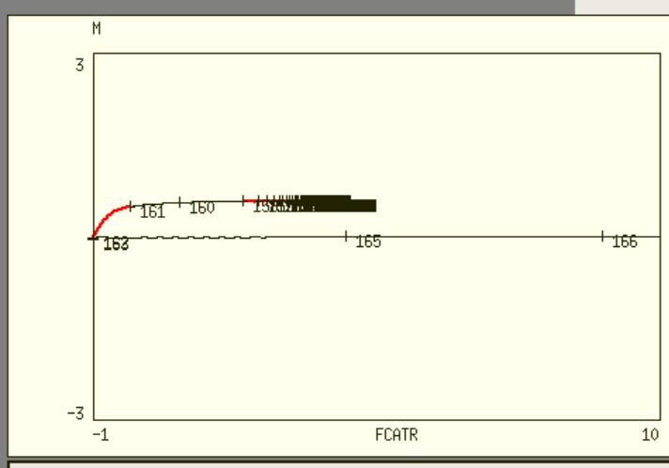

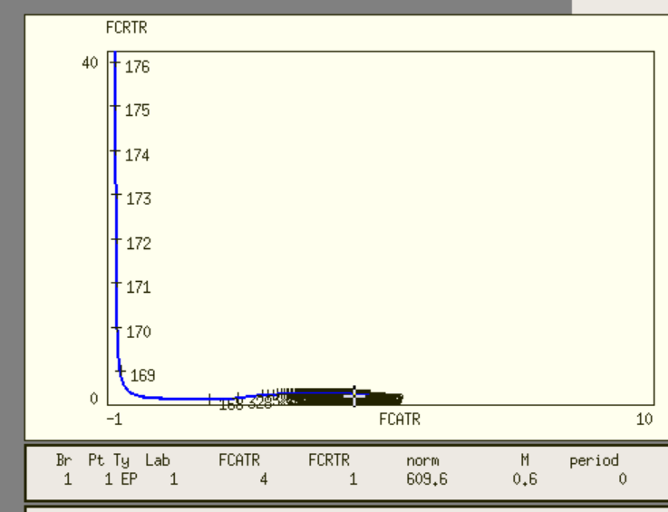

case 2

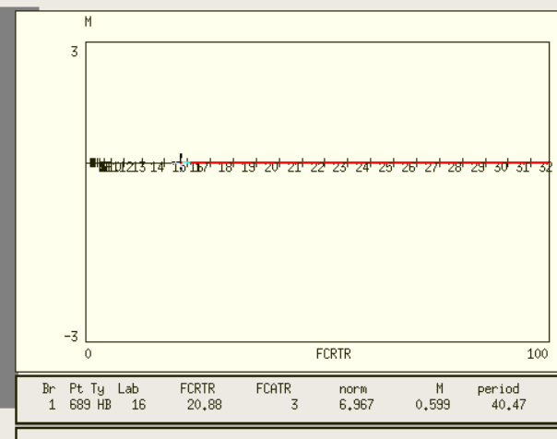

case 3

